Remote Control Car with GPS:
Instruction Manual

By
David Gitz and King Leung

For Dr. V.S. Gupta
October 28, 2008
495C: Technical Writing and Presentation Seminars

Table of Contents

I. Introduction……………………………………………………………………………………………………………..i
II. Background……………………………………………………………………………………………………………..i
III. Overview………………………………………………………………………………………………………………..i
IV. General Safety Remarks………………………………………………………………………………………..i
V. Sequence of Steps………………………………………………………………………………………………….ii
A. Hardware/Software Setup………………………………………………………………………………..ii
B. Using the System…………………………………………………………………………………………..…iii
i. Network Initialization……………………………………………………………………………………iii
ii. Manual Control…………………………………………………………………………………………….iv
C. Initializing the System………………………………………………………………………………………iv
VI. Troubleshooting…………………………………………………………………………………………………….vi

i.
I. Introduction:

This instruction manual is for the safe operation of the RC Car w/ GPS (herein the System) as built by SIUC Senior Design Team 73. As the device is intended for scientific/engineer market, basic safety precautions will be assumed to be unnecessary, as well as the operation of a PC. However, some knowledge of National Instrument’s (NI) LabView software will be necessary for the reliable operation of the vehicle. The System is designed for a user with limited knowledge of the LabView software package, along with some experience in robotics.

II. Background

The user should be familiar with NI LabView and the operation of a normal remote control vehicle.

III. Overview:

This document will cover the following material: General Safety remarks, Setup instructions, Explanation of the User Interface, Usage instructions, and Troubleshooting. Proper care should be taken in operating the System in an outdoor environment. The Vehicle is fairly water-resistant, but contact with water/mud should be avoided.

Parts, Materials, and Tools Required:

The following items are required for the optimal operation of the System:

- Laptop w/ USB, and (optional) power cable.
- Zigbee software driver installed on Laptop.
- Laptop with Wi-Fi access.
- Xbee Radio attached to Laptop.
- NI LabView version 8.5 installed on Laptop.

IV. General Safety Remarks:


The System is generally quite safe, although there are a few notes of interest. First, the battery packs are Nickel-Metal Hydride
(Ni-Mh), and, while quite safe, can be potentially hazardous if the proper care is not maintained. Please follow all safety regulations with the use and disposal of Ni-Mh batteries. Second, although the power draw on the System is quite low, be careful to avoid contact with any exposed metal on the System to limit the possibility of electrical shock. Lastly, as this is a product with mechanical and moving parts, please be aware of the possibility of the wheels spinning when using and/or maintaining the System.

ii.
V. Sequence of Steps:
- Hardware/Software Setup

To properly operate the System, the Vehicle must have 2 9.6V Ni-Mh battery packs installed. Also, the Kill Switch on the Vehicle must be de-activated.
1. Ensure that LabView version 8.5 (or higher) is installed on a user laptop.
Note: If a lower version of LabView is used on the laptop, the User Interface will not operate
correctly.
2. Connect a XBee Radio to the laptop using the provided USB Cable.
3. Start the “UserInterface.intfc” Project in LabView.
4. In the Project Manager, navigate to the folder "MainPanels" and open "networkinit.vi" and
"manualcontrol.vi" files.
Note: If there is a "File Not Found" warning when opening these files, please see the
Troubleshooting Section.
5. Insert 2 9.6V Ni-Mh Battery Packs into the lower Battery Compartment, observing the
correct polarity on the connectors.
6. De-activate (Pull) the Kill Switch on the top of the Vehicle.

iii.
B. Using The System

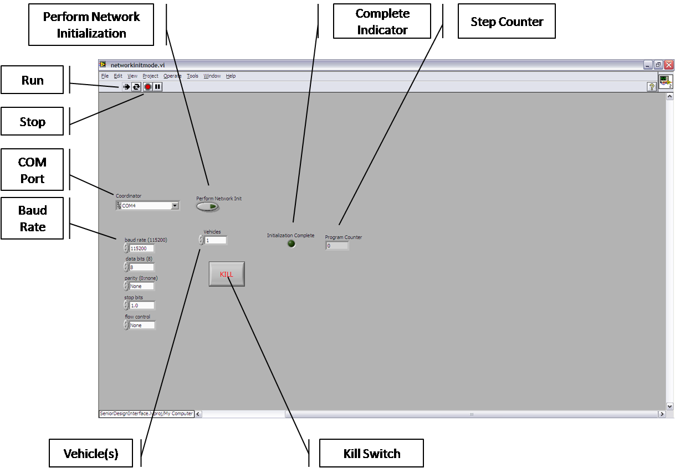

Fig 1: Network Initialization

i. Network Initialization – See Figure 1.
1. Run: Starts the Program.
2. Stop: Halts Program Execution. NOTE: Using this may result in unstable System
operation.
3. COM Port: Used to select the COM Port that the XBee Radio is connected to.
4. Baud Rate: The communication rate the User desires. Default value is 115200 kBps.
5. Vehicle(s): How many Vehicles are in the System.
6. Kill Switch: Safely Halt the execution of the Program.
7. Perform Network Initialization: Start Network Initialization.
8. Complete Indicator: Indicates that Network Initialization is Complete.
9. Step Counter: Increments every time the Program starts over.

iv.

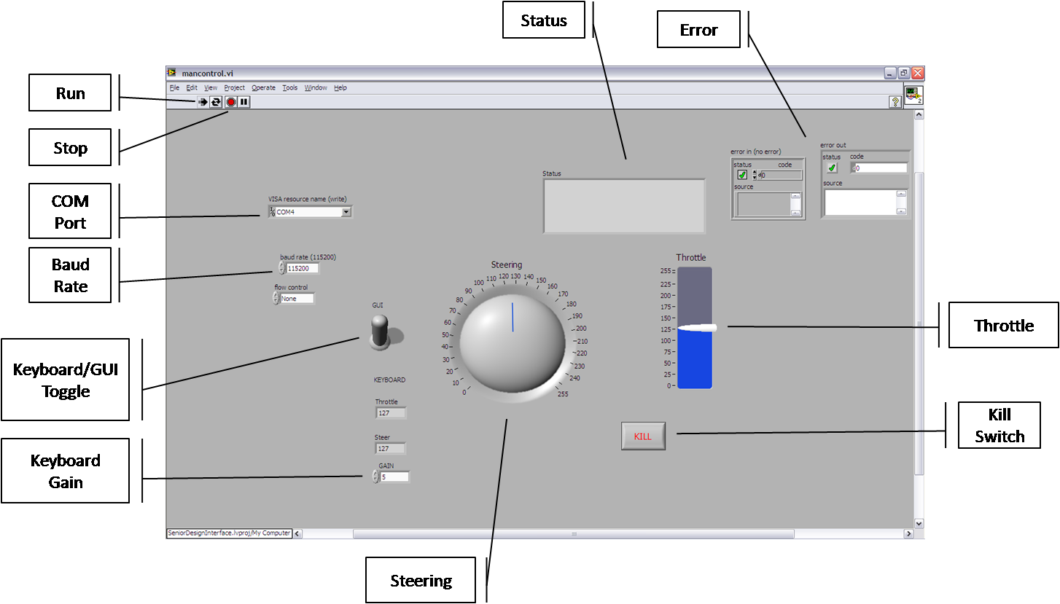

Fig 2: Manual Control

ii. Manual Control – See Figure 2.

1. Run: Starts the Program.
2. Stop: Halts Program Execution. NOTE: Using this may result in unstable System
operation.
3. COM Port: Used to select the COM Port that the XBee Radio is connected to.
4. Baud Rate: The communication rate the User desires. Default value is 115200 kBps.
5. Keyboard/GUI Toggle: Switch between using the Directional keys and the GUI Controls.
6. Keyboard Gain: Define how much each key press is worth.
7. Steering: Control the direction the Vehicle will move in.
8. Throttle: Control the speed of the Vehicle.
9. Kill Switch: Safely Halt the execution of the Program.
10. Status: Displays any transmitted informational messages.
11. Error: Displays any error that the Program encounters.

C. Initializing the System

Perform the following steps to initialize the system if it has not been done so already. If the
complete initialization process has already been completed, please go to Section IIB-6.
1. If not already done so, perform the Hardware/Software Setup as described in Section I.
2. Open the Network Initialization Panel.
3. Select the COM Port used for the XBee Radio.

v.
Unless there are other USB devices connected, there are most likely 2 COM Ports displayed, COM
Port 1 and COM Port x. Select COM Port x.
4. Select how many Vehicles are in the system.
Unless there are multiple Vehicles, select 1.
5. Run the Program.
Note: During the Program, the Green and Yellow LED on the Vehicle’s XBee Radio should light
up every few seconds. If this does not happen, see the Troubleshooting Section.
When it is completed, the “Network Initialization Completed” LED will light up. If it doesn’t after
30 seconds, see the Troubleshooting Section.
6. Close the Network Initialization Panel. Open the Manual Control Panel. Operate as desired.

If an Error Condition is displayed, see the Troubleshooting Section.

vi.

VI. Troubleshooting
Problem: | Solution:
- Vehicle won’t turn on. | - Make sure the battery is charged.  - Ensure battery is installed correctly.
- Vehicle does not move properly. | - Make sure the battery is fully charged.  - Check for obstructions in the wheels.
- LED’s on XBee Radio do not flash. | - Press the Reset switch on the XBee Radio.  - Refer to www.digi.com for more support information.
- "File Not Found" error in LabView. | - Perform a mass-compile on the User Interface, as described on www.ni.com/support  - Make sure LabView version 8.5 (or higher) is installed

